A Student’s Guide to Using TEAMS

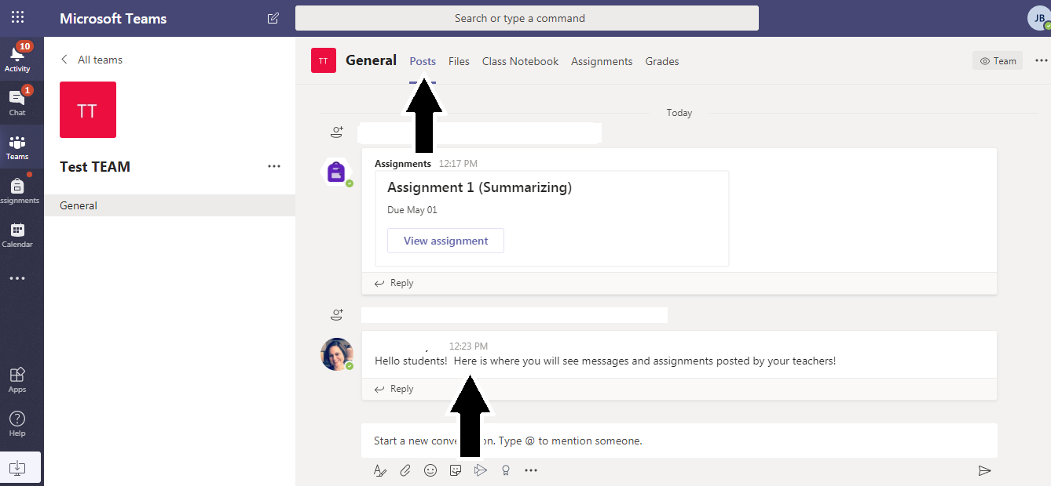
Posts: Here you will see messages from your teachers and assignments that he or she created.

Files: Here you can find files that your teacher uploads along with the instructional plan for each week.
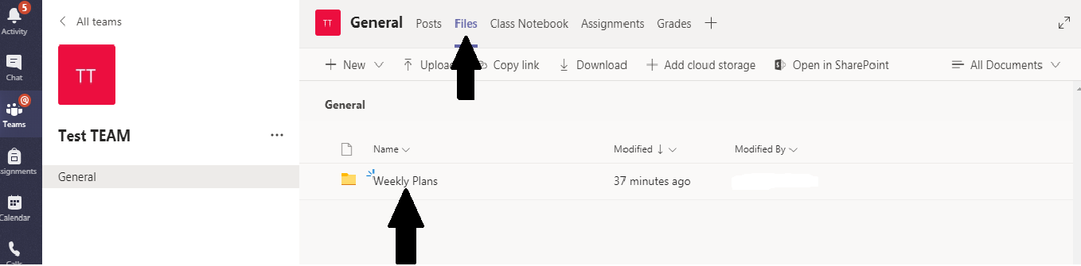

Assignments: Here you will see all of the assignments your teacher has given you along with any resources or instructional videos.

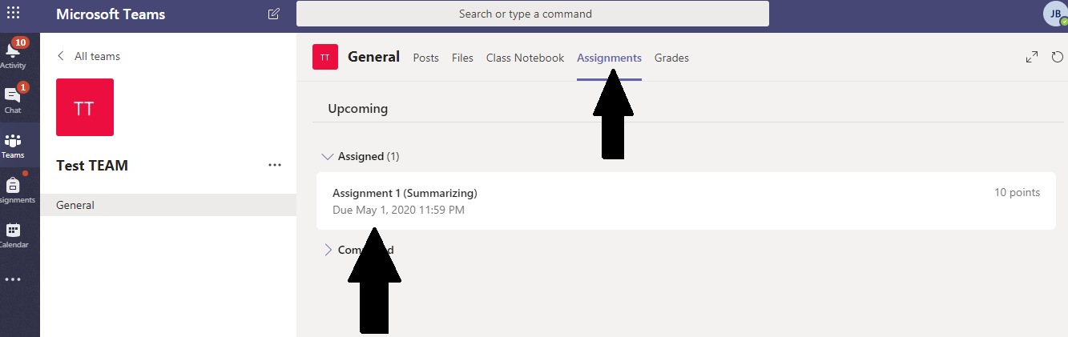

Grades: Here you will see all of your assignments along with the grades and teacher feedback.

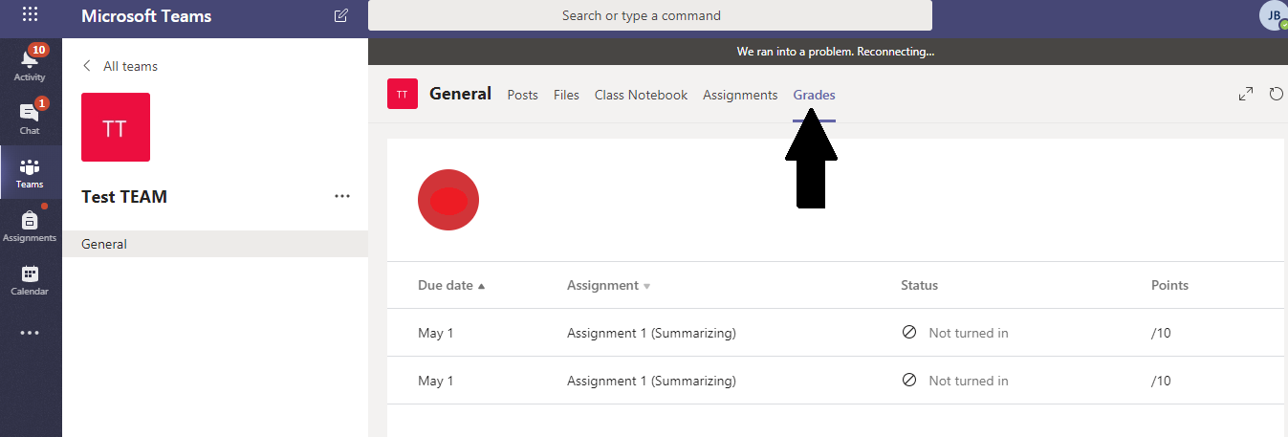

How to Complete an Assignment

Step 1: Click on the assignment you want to complete.

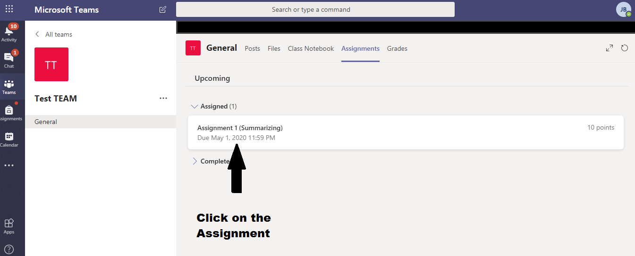

Step 2: Click the assignment you want to complete.

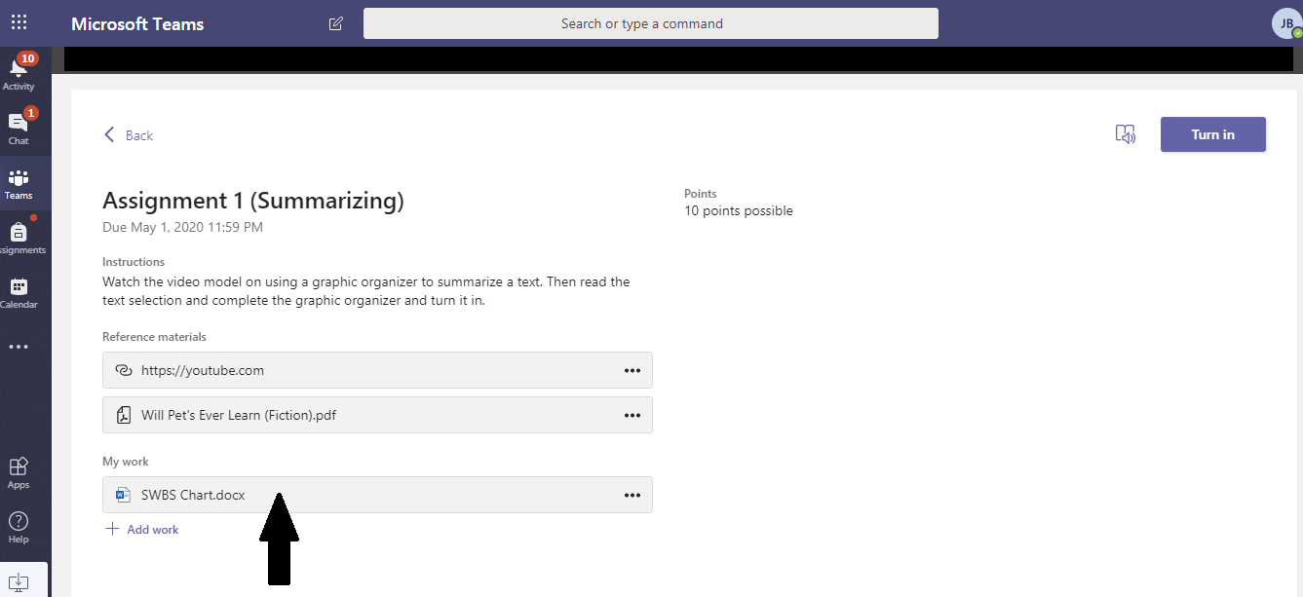

Step 3: Click “Edit Document” and select either option.

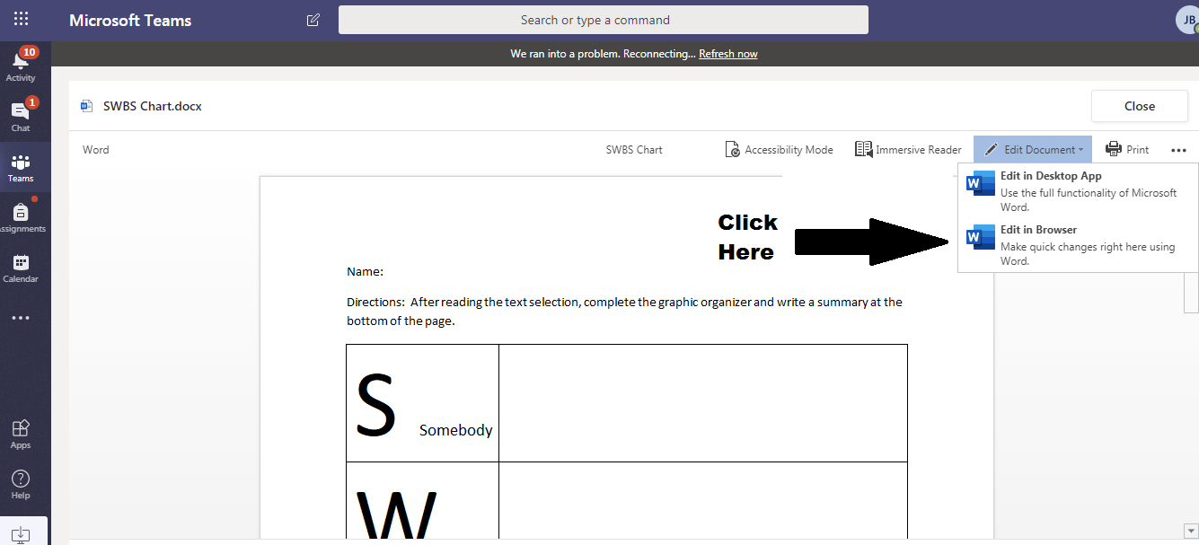

Step 4: Complete the work. The document will save automatically without the need to hit the “Save” button.

Step 5: Close the document when you have finished.

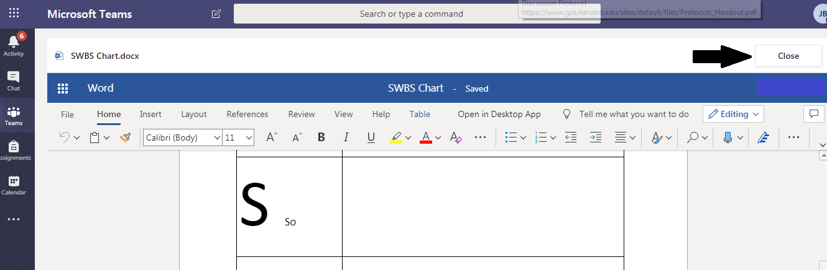

Step 6: Turn it in for your teacher to assess and give you feedback!

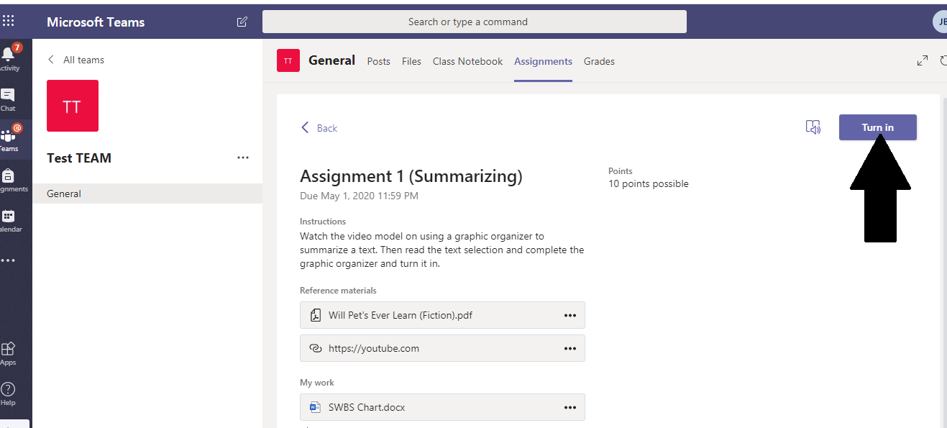

Step 7: Enjoy your virtual learning experience using TEAMS!

